**INDUSTRIAL TRAINING REPORT**

**ON**

**STUDY OF HYDRO – MECHANICAL EQUIPMENT**



**Submitted to :- Submitted by:-**

HM Design Department Anurag Chauhan

SJVN Ltd.

Shimla, Himachal Pradesh

***INDEX***

|  |  |  |
| --- | --- | --- |
| **S.NO.** | **CONTENTS** | **Page No.** |
| 1. | Acknowledgement |  |
| 2. | Objective |  |
| 3. | Introduction |  |
| 4. | Chapter 1:SJVN’S Hydroelectric Projects |  |
| 5. | Chapter 2 : Introduction to Hydraulic Gates |  |
| 6. | Chapter 3 : Types of Gates |  |
| 7. | Chapter 4 : Hoists |  |
| 8. | Chapter 5 : Nathpa Jhakri Hydro Power Station- Case Study |  |
| 9. | Conclusion |  |

***ACKNOWLEDGEMENT***

This project would not have been possible without people who were instrumental in giving me this wonderful learning experience.

I am grateful to ME Department, Chitkara University, Rajpura for giving me the opportunity to undergo industrial training at SJVN Ltd., Shimla. Also I’m thankful to SJVN Ltd., Shimla for allowing me to undergo training under the organization.

I owe my thanks to Mr. Bijay Prasad (AGM Training) and Mr. Anurag Bhardwaj (Sr. Manager HR) SJVN Ltd., Shimla for allowing me to undergo training under this organization.

I am grateful to Er. Arun Kumar (DGM), Er. Rajeev Kumar (Sr. Manager), Er. Yogesh Gupta (Sr. Manager) and Er. Ram Singh Kaushal (Sr. Manager) HM Design Department for enrolling me as student trainee in this organization and I am thankful for all their help during the training period.

I would like to express my sincere gratitude to Er. Manoj Kumar (Sr. Manager) HM Design Department who guided me in all the training aspects and always helped me tackle any difficulty whatsoever.

Last but not the least I thank all the employees of SJVN Ltd. for always providing me a warm environment in the workplace and always supporting me during the training period.

***OBJECTIVE OF THE TRAINING***

The main objective of the industrial training is to have practical exposure to understand how an industry works. The industrial training also helps in learning skills oriented to the needs of an industry.

Industrial training is a great opportunity to develop the required practical skills and gaining the necessary confidence to deal with people in your field. Curiosity to learn new technologies and keep engaging myself in such activities is my motivation to work in this field. I believe that the knowledge and skills which I would learn as an intern will provide me with the necessary tools to perform well and will allow making a significant contribution to your company.

***INTRODUCTION TO SJVN LTD.***

The Satluj JalVidyut Nigam Limited SJVNL (formally Nathpa Jhakri Power Corporation Limited – NJPCL), a Mini Ratna, Category-1 and Schedule-A under administrative control of Ministry of Power, Govt. Of India was incorporated on May 24,1988 as a joint venture of the Government of India and the Government of Himachal Pradesh. SJVN is now a listed company having shareholders pattern of 62.68% with Government of India, 26.85% with Government of Himachal Pradesh and rest 10.47% with Public.

Beginning with a single Project and single State operation (i.e. India’s largest 1500 MW Nathpa Jhakri Hydro Power Station in Himachal Pradesh) the Company has commissioned four projects totalling 2003.2 MW of installed capacity. SJVN is presently implementing Power Projects in Himachal Pradesh, Uttarakhand, Bihar, Maharashtra and Gujarat in India besides neighbouring countries viz. Nepal and Bhutan totalling 4018 MW.

|  |  |  |
| --- | --- | --- |
| Sr.No. | Project | Installed Capacity (in MW) |
| 1. | Nathpa Jhakri Hydro Power Station | 1500 |
| 2. | Rampur Hydro Power Station | 412 |
| 3. | Khirvire Wind Power Project | 47.6 |
| 4. | Charanka Solar PV Power Plant | 5.6 |
| 5. | Sadla Wind Power Project* | 38 |

SJVN has expanded its horizons and envisions developing itself into a fully diversified transnational Power Sector Company in all types of conventional and non-conventional forms of energy along with Power Transmission. The total portfolio of SJVN is 6801.2 MW out of which 2003.2 MW is under operation, 1572 MW is under construction, 1848 MW is under pre-construction and investment approval and 1378 MW is under survey and investigation stage. Project wisedetail is as under:

|  |  |  |
| --- | --- | --- |
| Sr.No. | Project | Capacity(in MW) |
| Projects under construction | | |
| 1. | Arun-3 HEP | 900 |
| 2. | Naitwar Mori HEP | 60 |
| 3. | Kholongchhu HEP | 600 |
| 4. | Sadla Wind Power Project | 12(balance) |
| Projects under Pre-construction and Investment approval | | |
| 1. | Luhri Stage-I HEP | 210 |
| 2. | Dhaulasidh HEP | 66 |
| 3. | Devsari HEP | 252 |
| 4. | Buxar Thermal Power Project | 1320 |
| Projects under Survey and Investigation stage | | |
| 1. | JakholSankri HEP | 44 |
| 2. | Sunni Dam HEP | 382 |
| 3. | Luhri Stage-II HEP | 172 |
| 4. | JangiThopanPowari HEP | 780 |

***CHAPTER 1: SJVN’S HYDROELECTRIC PROJECTS***

* 1. **NATHPA JHAKRI HYDROELECTRIC POWER PLANT**

The Nathpa Jhakri Dam is a concrete gravity dam on Satluj river in Himachal Pradesh, India. The Nathpa jhakri Hydroelectric Station of 1500 MW capacity is the country’s largest hydroelectric power plant.A memorandum of understanding for execution of the Nathpa-Jhakri HEP Project was signed between Government of India and government of Himachal Pradesh in July,1991. Construction on the project began in the year 1993. The original plan called for a five-year construction period, but a rockslide shortly after the civil contract was signed required extensive stabilisation work and the project had to be redesigned. The project was finally commissioned in 2004 and officially dedicated to the nation by Prime Minister Dr.Manmohan Singh on May 28,2005.

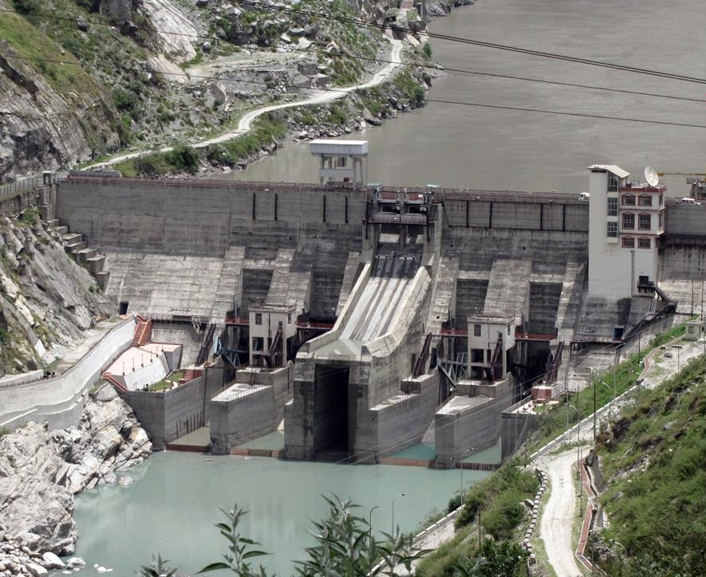

The Nathpa-Jhakri HEP has an installed capacity of 1500 MW produced by six Francis Turbines of 250 MW each. In July 2014, according to the company SJVN, it generated an all time record of power by producing 1191.217 million units against the target 1083 million units.

A large number of companies worked on the project. Kvaerner Energy of Norway provided the six 250 MW Francis Turbines and Kvaerner Boving of the UK provided the gates and valves, while the Eucona consortium of ABB, Kvaerner, Siemens, and Sulzer Escher Wyss won a US$200M main equipment contract. Canada’s Foundation Corporation and Impregilo of Itlay carried out the construction work, while Indian firms Hindustan Construction Company (HCC) and Bharat Heavy Electricals Ltd. (BHEL) also won contracts on the scheme.

The main components of this project are:

1. A 62.5 m high diversion dam on the Satluj River
2. Six 255 MW Francis Turbines
3. An underground desilting complex
4. A 27.4 Km long head race tunnel
5. A 982 m long tail race tunnel
6. A 301 m deep surge shaft
7. Steel lined pressure shaft
8. Underground power house and transformer hall

**NATHPA JHAKRI PROJECT: A Brief on Salient Features**

1. A 62.5 m high concrete gravity dam on River Satluj at Nathpa to divert 405 cumecs of water through four intakes.
2. A large underground de-silting complex, comprising four chambers, each 525 m long, 16.31 m wide and 27.5 m deep.
3. A 27.394 Km long head race tunnel of 10.15 m diameter terminating into surge shaft.
4. A 301 meter deep and 21.60 diameter surge shaft with an opening to the sky.
5. Circular steel lined 3 pressure shafts of 4.90 diameter each, bifurcating into two near the power house to feed 6 generating units.
6. An underground power house that has 6 vertical axis francis turbines of 255 MW each installed to utilize a design head of 426 metres.
7. A tail race tunnel of 982 meter length with 10.15 m diameter.

**PROJECT BENEFITS**

Besides the social and economic upliftment of the people in its vicinity, the 1500 MW Nathpa-Jhakri Hydroelectric Power Plant has been designed to generate 6612 Million Units(MU) of electrical energy in a 90% dependable year with 95% machine availability. It is also providing 1500 MW of valuable peaking power to the Northern Grid.

Out of the total energy generated at the bus bar, 12% is supplied free of cost to the home state i.e. Himachal Pradesh. From the remaining 88% of energy generated, 25% is supplied to Himachal Pradesh at bus bar rates. The remaining balance power has been allocated to different states and union territories of Northern Region by Ministry of Power, Government of India as mentioned below:

|  |  |  |  |
| --- | --- | --- | --- |
| Sr.No. | State | Allocation  (in MW) | Percentage of the Installed Capacity |
| 1. | Himachal Pradesh | 547 | 4.27 |
| 2. | Haryana | 64 | 36.47 |
| 3. | Jammu & Kashmir | 105 | 7.00 |
| 4. | Punjab | 114 | 7.60 |
| 5. | Rajasthan | 112 | 7.47 |
| 6. | Uttar Pradesh | 221 | 14.73 |
| 7. | Uttarakhand | 38 | 2.53 |
| 8. | Chandigarh | 8 | 0.53 |
| 9. | Delhi | 142 | 9.47 |
| 10. | Unallocated quota at the disposal of the Central Govt. | 149 | 9.93 |
|  | TOTAL | 1500 | 100 |

Besides above, indirect benefits have also accrued to the region by way of increase in agriculture and industrial production. In addition, the project has provided gainful employment to a large number of skilled and unskilled workers and has also opened the landlocked hinterland by providing essential facilities such as schools, hospitals etc. for the local people. Thus NJHEP has ushered in the social and economic up-liftment of the persons living in the vicinity of the Project.

**1.2 RAMPUR HYDRO ELECTRIC PROJECT (RHEP)**

The 412 MW Rampur Hydro Electric Project is located on River Satluj, a major tributary of Indus basin, in Shimla and Kullu district of Himachal Pradesh in North India. The project is designed as a cascade run of the river plant to India’s largest hydroelectric power plant, the 1500 MW Nathpa Jhakri HEP. The Rampur project has the potential to generate 1878 million units of electricity each year.

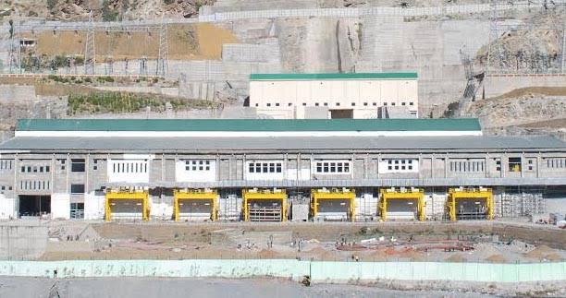

The Rampur Hydroelectric Project involves financing of the project on a 70:30 debt-equity ratio basis. The Rampur Project is backed by the World Bank. Construction of Rampur Project began in February, 2007 and commissioned by March 2014. The Rampur is a very environment friendly project as it does not involve construction of any diversion dam or any de-silting chambers and does not inundate any land.

**1.3 LUHRI STAGE-1 HYDRO ELECTRIC PROJECT**

The Luhri Project with a generation potential of 210 MW is located on River Satluj, a major tributary of Indus basin, in Shimla/Kalka/Mandi district of Himachal Pradesh in North India. The project is designed as a standalone run of the river project.

**1.4 DEVSARI HYDRO ELECTRIC PROJECT**

The Devsari Project with a generation capacity of 252 MW is located on River Pinder, on Ganga basin, in Chamoli district of Uttarakhand state in North India. The project is designed as a standalone run of the river project. The Devsari project has the potential to generate 936.90 million units of electricity each year.

A Memorandum of Understanding (MOU) for execution of Devsari project was signed with the Government of Uttarakhand on November 21, 2005. The estimated cost of the project at June, 2012 price levels is Rs 1790.09 crores. Construction period of the project is 5 years.

**1.5 NAITWAR MORI HYDRO ELECTRIC PROJECT**

The Naitwar Mori Project with a generation potential of 60 MW is located on River Tons, a major tributary of River Yamuna on the Ganga basin, in Uttarkashi district of Uttarakhand state in North India.

The project is designed as a standalone run of the river project. The Naitwar Mori project has the potential to generate 265.5 million units of electricity each year. A Memorandum of Understanding (MOU) for execution of Naitwar Mori project was signed with the Government of Uttarakhand in November 21, 2005. The estimated cost of the project at March 2012 price levels is Rs 664.6 crores. Construction period of Naitwar Mori project is 4 years.

**1.6 ARUN – III HYDRO ELECTRIC PROJECT**

A Memorandum of Understanding (MOU) for execution of 900 MW Arun – III project was signed with the Government of Nepal on March 2, 2008. Proposed to be located in the SankhuwasabhaDistt. Of Nepal which is 657 Km from Kathmandu via Birat Nagar. The Survey license for generation was issued by Govt. Of Nepal during July 2008 and extended upto 17.07.2013.

***CHAPTER 2:INTRODUCTION TO HYDRAULIC GATES***

* 1. **HISTORY AND DEVELOPMENT**

The construction of hydraulic gates was closely related with the development of irrigation, water supply and river navigation systems. In the early days of hydraulic engineering, water was backed up by small dams and conveyed to side irrigation canals. The excess water was discharged over the dam. As a natural evolution, ‘movable dams’ were built. These movable dams could be removed from their normal position to provide passage for excess water, thus permitting greater safety and flexibility in the operation of hydraulic works.

The first canals for transportation of goods and drainage of floodwaters were built in China. Around the year 0983, the Chinese discovered that by constructing two dams a certain distance apart, the boats could enter the pool created between them and the water level could be slowly increased or decreased. The earliest dams had wood or stone piers on each side of the canal. Vertical grooves were cut into opposite sides of the banks and tree trunks were fitted horizontally into the grooves, which held the water at the highest level. Ropes were used to lift the trunk. Later the trunks were linked forming an integral barrier that could be lifted or lowered as a single unit like a guillotine blade.

The development of gates in the Netherlands fallowed a pattern similar to that of China. At the end of the 14th century, locks were very common there. The gates still of the guillotine type, were provided with lead counterweights and equipped with drains, which permitted emptying gradually the lock chambers.

The first metal gates appeared around 1830. With the turn of the century, various inventions occurred as well as a great development of the existing types, furthered by the challenge of the need to build ever-larger gates.

Filipo Maria Visconti designed the first pound lock in 1439 at Vareno, near Milan, Itlay, to improve navigation for the transportation of granite blocks used in the construction of the Milan’s Duomo.

The oldest known application of segmented gate was in 1853, on the Seine River, in Paris, where four gates 8.75 m wide by 1.0 m high were installed. These were designed by the French Engineer Poiree, who also invented the needle dam first used in 1834 on the Yonne River, in France. Around 1870 in the USA parallel inventions of the segmented gate occurred. The gate had three radial arms and wood construction. It was driven by chains installed upstream of the skin plate. The gates would be installed in tandem to serve as lock gates and also for filling and emptying the lock chamber.

Double-leaf gates originated in Europe, and are found in Japan. Double-leaf metal gates, 5 m wide by 5 m high, were used to close the 111 arches of the Assiout Dam, Egypt, in 1902. In 190, ten double fixed–wheel gates were installed on the Augst-Wyhlen Dam, on the Rhine River, Switzerland, each gate being 17.5 m wide and 9 m high. The modern double fixed-wheel gate of the hook type was developed by M.A.N. and installed for the first time on the Reckingen Dam, Switzerland, in 1930.

The sector gate was invented in the USA by C.L. Cooley, and used for the first time in 1907 in the Lockport Dam on the Chicago drainage canal. In Europe the first application of the sector gate was in 1911, when two gates were installed on the Weser Dam, near Hemelingen, Germany, with a 54 m span and 4.6 m height.

The ring gate is a variation of the cylinder type and was developed by the Bureau of Reclamation, USA, for use in morning-glory spillways. Only two applications are known, both in the US: Owyhee Dam(in 1936), with a diameter of 18 m and a height of 3.6 m; and Hungry Horse Dam(in 1953), with a diameter of 19.5 m and a height of 3.6 m.

The Stoney gate is named after after its inventor, Mr. F.G.M. Stoney. These gates were first constructed in 1883 at Belleek, Ireland. Four sluice gates were placed between masonry piers to control the outfall from a chain of lakes. Each gate was 8.9 m wide and 4.4 m high. They were made of iron plate and beams. Stoney gates were extensively used in Europe, USA, Egypt and India at the beginning of the 20th century.

**2.2 GATE COMPONENTS**

A gate consists basically of three elements: leaf, embedded parts and operating device.

* **Leaf**: The leaf is a movable element that serves as bulkhead to the water passage and consists of skin plate and girders. The shield plate directly responsible for the water dam is called the skin plate. The seals, the components responsible for the water tightness, consist generally of rubber strips screwed on to the skin plate. Onthe gate leaf are also attached the support elements (wheels, rollers, bearing plates) and guides (shoes, wheels, springs etc.)
* **Embedded Parts**: The embedded parts are the components embedded onto the concrete, which serve to guide and house the leaf, to redistribute to the concrete the forces acting on the gate. It also acts as protection to the concrete edges and support element for the seal. The basic components of the embedded parts are: sill beam, wheel or slide tracks, side guides, counter guides, lintel, seal seat and slot lining.

The sill beam is the lower horizontal element of the embedded parts and serves as support for the gate leaf or the bottom seal. The wheel or slide tracks acts as support element and distributor of the loads transmitted by the wheels or rollers. The side guides and counter guides limit the displacement of the gate leaf on the horizontal plan and are designed to absorb the corresponding stresses. The lintel is an element used only in submerged gates and serves to complete, along with the side guides and the sill, the water passage frame. It is located on the upper horizontal portion of the passage to be closed, supports the upper seal and serves also for the protection of the concrete against erosion caused by the water flowing at high speed.

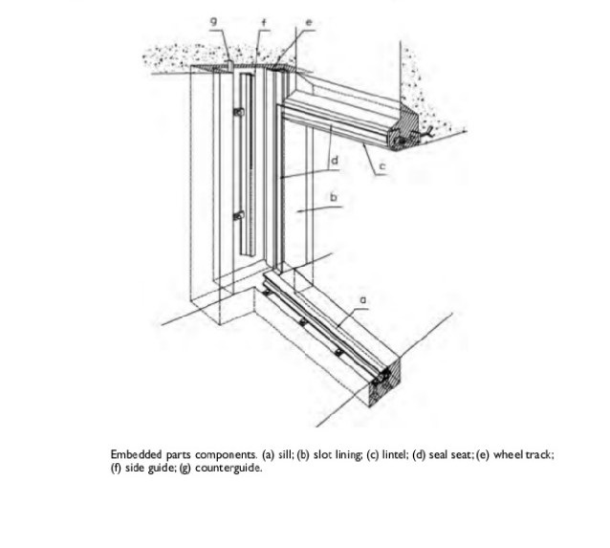

* **Operating Device**: the operating device is the means directly responsible for the opening and closure of the gate. Some gates dispense with the use of operating hoists and are moved by water pressure, such as sector, drum and bear-trap gates.
  1. **MAIN APPLICATIONS**

Gates find a wide range of application in the various fields of hydraulic engineering. Some of the applications are listed below:

1. Flood protection works
2. Protection of equipment – emergency gates installed upstream of turbines
3. Level control in reservoirs intended for recreation or located near residential or non-flooding areas
4. Maintenance of constant level in reservoirs
5. Cleaning of reservoirs- discharge gates for floating debris (trees boughs, trunks and ice)
6. Flow regulation in dams
7. Equipment maintenance – stoplogs installed downstream of turbines, upstream of spillway gates etc.
8. Closure of river diversion conduits
9. Intake works for hydroelectric plants, water supply etc.
10. Irrigation – water intake, head control, distribution etc.
11. Navigation dams – lock gates, filling and emptying systems etc.
    1. **TYPES AND CLASSIFICATIONS**

According to their features, the gates may be grouped in various manners. The following classification criteria may be listed: purpose, mode of operation, movement, water passage, gate leaf composition, head available and skin plate shape.

* + 1. **PURPOSE**

According to their operational purpose, gates may be classified as:

1. Service Gates: Service gates are used for continuous regulation (partial openings) of flow or water level such as main gate for regulation of the flow through spillway, sluices, outlets etc. Examples:

* Spillway gates
* Bottom outlet gates
* Lock gates (navigation chambers and aqueducts)
* Flood control automatic gates

1. Emergency Closure Gates: These gates are used occasionally to shut down the flow of water in conduits or canals; as a rule they are designed for normal operation in open or closed position. Only in special situations these gates can be used in partial openings as, for instance, the intake gates where the filling of the penstock is provided through slight lifting of the leaf (operation called ‘cracking’). The following gates are considered emergency gates:

* Intake gates
* Gates installed upstream of penstock service valves
* Draft tube gates of Kaplan turbines
* Gates installed upstream of bottom outlet gates

1. Maintenance Gates: Bulkhead gates, stoplogs which are used for maintenance of main gates/butterfly valves/turbines etc. Bulkhead gate, stoplogs are used at upper section of intake gates, spillway/sluice gates, surge shaft gate for maintenance of butterfly valve and Draft Tube Gate for maintenance of Turbines. In addition to above, in SFT conduits the bonneted type slide gates are also used as guard/maintenance gates for Service gates.
2. Construction Gates: Required to close opening during construction of the project or to finally close the opening after construction such as diversion tunnel gates, construction gates at outlet of TRT.
   * 1. **MODE OF OPERATION**

According to the mode of operation, the gates are classified as:

1. Regulating Gates: Regulating Gates are those gates which can be operated under partial gate openings. Generally the regulating gates are the service gates. Examples – Sluice Radial gates, Spillway gates, SFT service gate.
2. Non Regulating Gates: Gates not intended for operation under partial gate openings. Examples – Surge Shaft gates, Draft Tube gates, TRT gates, Stoplogs, Bulkhead gates.
   * 1. **MOVEMENT**

According to the movement of the gate along its guides, the gates are classified as:

1. Translation Gates: Translation gates may be either sliding or rolling. In the sliding gates, the gate leaf moves along the guides overcoming the friction of sliding between embedded and movable parts through shoes or bearing plates, whereas the rolling gates use wheels or rollers for that purpose.

* Sliding: slide, stoplog, cylinder
* Rolling: fixed-wheel, caterpillar, Stoney

1. Rotation Gates: In the rotation gates, the gate leaf turns around a fixed axis, called hinge axis. In the flap, sector, drum and bear-trap gates, the hinge axis lies on the sill, in a horizontal position. In the mitre gates, the hinge axes (one for each gate leaf) are vertical and located near the lock chamber walls. Visor and segment gates are provided with a horizontal hinge axis located above the sill. In some rarecases segment gates were designed with vertical hinge axes assembled in pairs to serve as lock gates, as in the La Rance Lock, in France.

* Rotation Gates: flap, mitre, segment, sector, drum, bear-trap, visor

1. Translo-Rotation Gates (Roller Gates): The roller gate is the only gate that performs a combined motion of rotation and translation. Its leaf is a cylindrical structure with a horizontal axis that turns in a rack gear installed in an inclined recess in each end pier.

* + 1. **WATER PASSAGE**

According to the water passage in relation to the leaf position, the following situations may occur:

1. Discharge over the leaf – flap, sector, bear-trap and drum gates, in the opening operation they move down around the hinge axis located on the sill, permitting the water passage over the gate.
2. Discharge under the leaf – slide, caterpillar, roller, segment, fixed-wheel, visor and Stoney gates move upwards, making possible the flow of water under the gate.
3. Discharge over and under the leaf – mixed and double gates permit discharge alternately over and under the leaf, according to the operational requirements.
   * 1. **GATE LEAF COMPOSITION**

Gates may be plain, mixed or double, depending on the amount and type of elements that comprise the leaf. The plain gates have the leaf with only one element. In the mixed ones, the main leaf has, at the top, a flap gate. Many applications are known of segment, fixed – wheel, roller and Stoney combined with flap gates, mainly in Europe. In double gates the leaf comprises two movable overlapping elements. The lowering of the upper element permits discharge over the gate, while the lower element can be lifted to discharge as an orifice. Both the elements are raised for passage of the maximum flow. Fixed – wheel and segment gates are the only known types of double-leaf gates.

* + 1. **HEAD AVAILABLE**

According to the water head available over the sill, gates are usually classified as:

1. Low head gates: Head less than 15 m e.g. – Barrage gates, spillway gates.
2. Medium head gates: Head between 15 m and 30 m e.g. – intake gates, draft tube gates and penstock gates.
3. High head gates: Head more than 30 m e.g. – sluice gates, outlets gates, surge shaft gates.

The above classification is only a general attempt to classify under different head available and are subjective to change according to the technological evolution.

* + 1. **SKIN PLATE SHAPE**

According to the shape of skin plate, the gates may be classified as:

1. **Vertical Lift Gates**: It consists of vertical skin plate (to the flow) supported by horizontal girders, end vertical girders etc. The vertical lift gates are further classified as Fixed Wheel Gates and Slide Type Gates.
2. **Radial Gates**: The radial gate consists of curved skin plate supported by horizontal girders, vertical stiffeners and radial arms, Trunnion, Trunnion girder etc.
3. **Hinged Gates**: This type of gate is mounted on hinges and rotates about hinges. This type of gate is used at face of HRT to facilitate the inspection. E.g. – HRT Adit Gate.
4. **Flap Gates**: These gates are having arc shaped skin plate supported by horizontal girders, vertical stiffeners and rotates about the hinges at the sill beam. E.g. – Auxiliary Spillway gate, Debris flushing gates.

***CHAPTER 3: TYPES OF GATES***

**3.1 FLAP GATES**

This type of gate consists of a straight or curved retaining surface, pivoted on a fixed axis at the sill. When designed with a leaf with a shape of a fish belly, it can be operated from one end for spans up to 20 m, since the closed shell structure offers high resistance against torsion. The bearings are rigidly anchored to the sill and spaced from 2.5 m to 4 m.

In its fully raised position, the flap gate makes an angle from 60 to 70 degrees with the horizontal. In the fully lowered position, the skin plate forms a continuous surface with the weir bottom, presenting no obstacle to the water flow.



Similar to the drum and sector gates, the water flows over the flap gate when it is open. Seals are provided at the lower edge and the sides of the gate leaf. The lower seal may be made with a rubber strip bolted to the sill and the skin plate (fig. 2.2), or with one end abutting on the cylindrical surface of the skin plate lower position (fig. 2.3). A cover plate usually protects the lower seal.

Floats may be incorporated into the hoisting mechanism to provide automatic operation. Flap gates are often equipped with counter weights, to reduce the operating forces, as shown in (fig. 2.4)

Metal or rubber side seals, attached to the side end plates of the leaf, permit side sealing at all gate positions. If side sealing is desired only at the fully closed position, the seals may be mounted in the piers (fig. 2.5).

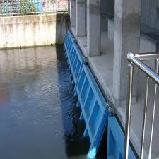

Flap gates operating partly opened may be subjected to severe oscillations, due to the creation of a low-pressure zone under the overflowing water. This problem can be eliminated or minimized through the construction of air vents with exits at the piers or with the aid of metal pieces installed on the gate leaftop, spaced from 2 m to 4 m, and designed for the purpose of breaking the stability of the overflowing water nappe (fig. 2.6 – 2.7).

Flap gates are also used on the top of segment and fixed – wheel gates. These gates so formed present great operational flexibility, for they permit:

1. Precise regulation of the reservoir level, through gradual lowering of the flap gate, which discharges with a low water head.
2. Passage of ice and other floating material, by lowering of the flap gate, with little loss of the reservoir water.
3. Discharge of a large water volume, by lifting of both gates.

Flap gates used as the main element of spillway control have their maximum height limited to about 5 m; yet they may be built for large spans, 50 m or more. The largest flap gate ever manufactured is that of St. Pantaleon, Austria, with a 100 m span and a 3.7 m height. The highest gate is that of Barenburg, Switzerland, with a 6.2 m span and a 7.2 m height.

**3.2 CYLINDER GATE**

The cylinder gate has a cylindrical-shaped leaf, which executes a vertical translation movement. Cylinder gates are generally intended for use in intake tower structures; they can be designed either for external of internal pressure.

The cylinder gate is usually raised by a series of vertical stems, which extend upward to the tower top, where their ends are connected to motor – driven screw lifts. Due to the cylindrical shape of the skin plate and its vertical arrangement, the hydraulic pressure is balanced. So, for movement of the gate, it is sufficient to overcome the weight of the gate and stems, seals and guide friction and downpull forces arising during opening or closure.

Gate stems are guided by bearing fixed in the lower structure and spaced as required to prevent buckling when the gate is being forced down against friction.



An interesting application of the cylinder gate is that installed in 1936 by the Bureau of Reclamation in the morning-glory spillway at the Owyhee dam, Orego, USA. The gate has an 18 m diameter and a 3.6 m height, and received the special name of ring gate. It is installed in a hydraulic chamber at the top of the spillway structure (fig. 2.11). Upon lowering of the gate, water is admitted into the spillway, passing over the gate structure. The gate is raised or lowered by buoyancy in water introduced in the hydraulic chamber from the reservoir, through a 600 mm diameter inlet pipe. Water is drained from the hydraulic chamber through two 600 mm diameter needle-type control valves, which in turn are controlled by a system of a float and control cables and sheaves. Metal seals are provided at the inner and outer lips of the hydraulic chamber. The seal on the inner side prevents the escape of water from the hydraulic chamber, and the seal on the outer side prevents entrance of reservoir water into the chamber. The gate is also provided with a vertical guiding device that keeps the gate level and, at the same time, prevents the gate from rotating in the chamber.

**3.3 STOPLOGS**

Stoplogs are primarily used for maintenance and repair of main equipment or gates. It can be used at:

1. Upstream of intake gates
2. Upstream of spillway gates
3. Upstream and downstream of bottom outlets, when the downstream water level is higher than the gate sill
4. Downstream of turbines or draft tube emergency gates

Their construction is similar to that of the slide gate. They do not have wheels or rollers, except in the infrequent and particular cases of sloped guides or of shutting-off the flow of water through lowering of the stoplog.

Depending on the height to be sealed, the stoplog may comprise more than one element. These are called stoplog panels. The height and quantity of stoplog panels are influenced by:

1. The lifting capacity of the crane or gantry crane
2. Gantry crane height – the higher the panel, the greater the lifting height above the operating deck
3. Difficulty of storing high panels
4. Transportation limits of the access ways to the site – the maximum normal width of parts to be conveyed by highway or railway is 3 m. In highways, if such limit is exceeded, a special transportation license is required, which increases transportation costs.

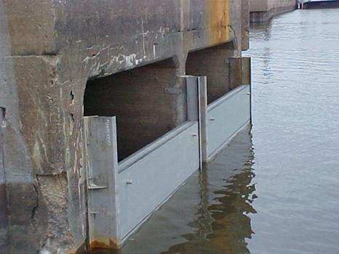

Stoplogs panels are placed and removed under balanced pressures, by means of cranes, travelling hoists or gantry cranes, with the help of lifting beams. The lifting beam is provided with lifting hooks operated by a system of levers and counterweight. It operates as follows:

1. To remove the panel – the lifting beam is suspended by the crane hoist and the counterweight is set to the position ‘close’. The beam is introduced into the guides and lowered till it hits the panel. The beam hooks then slide their sloped faces over the suspension lugs, rotating on their suspension pins until the hook ends penetrate the lug holes, when by action of the counterweight, the hooks regain the vertical initial position, fastening the panel.
2. To place the panel – with the panel suspended by the lifting beam, the counterweight is moved to the position ‘open’. The panel is introduced into the guides, being lowered until it reaches the lowest point of the guide length. Carrying on the lowering of the beam, the hook ends disengage from the lifting lugs and the counterweight commands the opening of the hooks, releasing the beam.

The balance of pressure required for removal of the panels after conclusion of the maintenance services is achieved through filling the space between the stoplog and the main gate or equipment with water. For submerged gates, the following filling systems may be used:

* By-pass valve installed in the upper panel, operated by the lifting beam(fig. 2.16)
* Flood valve embedded in the concrete structure.

In the particular case of weir stoplogs, the by-pass valve can be eliminated. Pressure balance is reached by cracking the upper panel, which creates a gap between this panel and the one immediately below. The comparatively low head acting on the upper panel facilitates this operation. This method is largely used in Brazil (for example, spillway stoplogs of the Estreito, Furnas, Porto Colombia and Itumbiara Power Plants).

**3.4 SLIDE GATE**

The slide gate is the simplest type of flat gate. It consists basically on a gate leaf that slides along side guides embedded or fastened to the concrete (fig. 2.18). The leaf is provided with sliding surfaces, usually metallic, which under tight contact at the bearing surfaces acts as seals.

Because of its simple and safe operation and its little maintenance required, the slide gate is largely used as a control device in irrigation canals, sewage works, bottom outlets and small intakes and reservoir spillways.

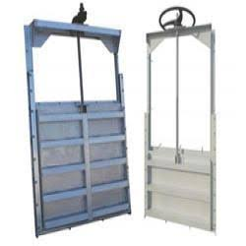

Other distinguished characteristics of the slide gates are the uniform transmission of the hydrostatic load to the concrete and the absence of vibrations in partial openings due to the large friction forces developed between the sliding surfaces. This feature is highly desired for bottom outlet gates, on the other hand, the slide gate is not recommended for installation requiring closure by gravity,due to the large friction forces created.

Slide gates may be made of timber, cast iron, cast steel or structural steel. Stainless steel sluice gates with ultra high molecular weight polyethylene (UHMWP) seals are made by H. FONTAINE, Canada. When seals and seats are metallic, materials of the same chemical composition should not be used in their manufacture. The seal material should be slightly softer than that of the seats, so as to avoid seizing of the mating surfaces under load and so that the wear take place on the seal and not on the seat.

An interesting example of slide gate is the bottom outlet of the Emosson dam, on the boundaries between France and Switzerland, near Chamonix. The main feature of these gates is the leaf construction. It was designed as a massive steel plate with no reinforcements. The advantages of this construction are the absence of any welding, the reduced size of the slots (which decreases the flow turbulence) and finally, the large deadweight with its enhanced effect on dynamic load resistance.

**3.5 CATERPILLAR GATE**

A caterpillar gate consists primarily of a leaf supported by vertical girders at the sides. Continuous roller trains of the caterpillar type are mounted around the vertical girders. The roller trains travel with the gate.

The low friction on the roller and their high load capacity recommend the use of the caterpillar gates in high-head installation requiring closure by their own weight, rather than fixed-wheelgates. The main disadvantages of this type of gate in relation to fixed – wheel gates are:

1. Higher initial costs
2. Higher maintenance costs resulting from a great quantity of movable parts
3. The need of high precision adjustment between the roller tread and the roller tracks for adequate operation
4. Possibility of failure in some rollers or pins that may compromise the operation of the roller train
5. Possibility of damage to the rollers due to eccentric loading resulting from gate leaf deflection, which requires the construction of horizontal beams of greater inertia.

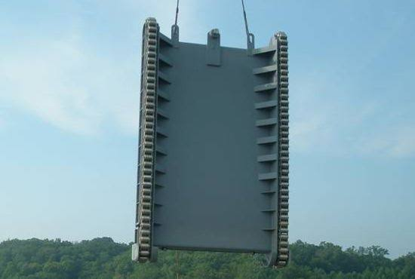

Caterpillar gates are generally designed as guard gates of high-head intakes and used only in the fully open or closed positions except for filling the conduit in the cracking operation and emergency closures. Normal opening and closure are carried out under balanced pressures. Emergency closures for shutting-off the conduit is made by gravity.

The caterpillar gate comprises basically skin plate, horizontal beams, vertical end girders, roller trains and seals. The skin plate may be placed upstream or downstream, as well as the seals. An interesting design is the caterpillar gate of the San Louis dam, USA, made in two sections, each with a pair of roller trains.

A special type of caterpillar gate was developed in the USA and received the name of Broome. This gate seats along its sides in a plane that is inclined relative to the plane of the tracks (fig. 2.26). As the leaf motion is always vertical, any upward displacement separates the seats from the seats, thus eliminating the seal friction.

In Brazil, the following caterpillar gates have been installed:

|  |  |  |  |  |  |
| --- | --- | --- | --- | --- | --- |
| Power Plant | Quantity | Span (m) | Height (m) | Head (m) | Manufacturer |
| Funil | 3 | 4.5 | 6.25 | 77.8 | ALSTOM |
| Marimbondo | 8 | 6.6 | 11.44 | 37.3 | Bardella |
| C.E.A.R.D. | 2 | 2.8 | 4.40 | 60.0 | Terni |
| Banabuiu | 2 | 3.0 | 3.00 | 59.0 | ALSTOM |
| Itaparica | 6 | 9.5 | 11.00 | 38.0 | BSI |

Amongst the largest caterpillar gates already built, the following are noteworthy:

|  |  |  |  |  |  |
| --- | --- | --- | --- | --- | --- |
| Year | Project | Span (m) | Height (m) | Head (m) | Outstanding Feature |
| 1938 | Genissiat | 11.6 | 8.9 | 67.5 | Span |
| 1948 | Tignes Les Brevieres | 2.5 | 3.0 | 156 | Head |
| 1965 | Guri | 5.5 | 15.7 | 65/85.5 | Height |
| - | Roseires | 8.3 | 14.8 | 54.5 | Area |

**3.6 MITER GATE**

The miter gate is used as navigation lock gates and comprises two rotating leaves with vertical hinge axes located in the lock chamber walls. In the closed position, the leaves meet at the center of the lock, supporting one another on the free ends, like a bishop’s miter, hence its name. In the open position, the miter gate leaves fit into the recesses built in the chamber side walls (fig. 2.28).

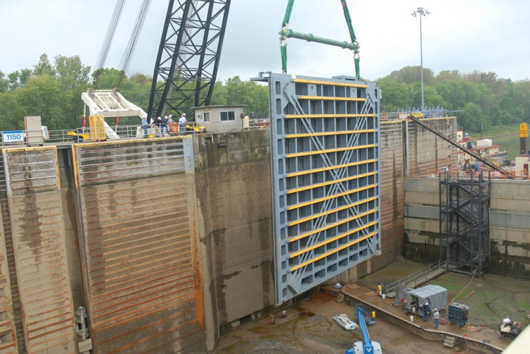

The main gate is fairly simple in construction and operation and can be opened and closed more rapidly than any other type of lock gate. Some disadvantages of the miter gate are:

1. Submergence of the pintle bearing, bottom seal, and lower part of the gate, which require unwatering for inspection and maintenance
2. Susceptibility of the bottom seal to damage from debris on the sill
3. Extra length of lock chamber required to open the leaves ( chiefly the downstream lock gate)
4. Its inability to close off flow in an emergency situation

Each leaf is usually supported at two points. A pin located near the leaf top and rigidly fastened to the gate passes through a collar bearing (gudgeon) anchored to the chamber wall. The lower part of the leaf presses against a thrust bearing (pintle), fixed to the sill. In certain cases, the lower support is made eccentric and designed so that the side seals move away from the seats when the movement of the gate opening starts.

**3.7 ROLLER GATE**

Roller gates are horizontal steel cylinders with toothed gears provided at each end. Racks are placed in the piers along the track recesses (fig. 2.35). These gates were used with success in northern countries, where large masses of floating ice and low temperatures used to hinder or even block the operation of conventional gates. They are generally used on low head dams and in installations where a wide opening between piers is desired for the passage of ice or debris.

The cylinder is hollow and made up of curved steel plates stiffened by longitudinal members and diaphragm frames attached to the inside surface. The cylinder may be filled with water to prevent floatation. The gate is sealed at the ends and bottom. Metal discs connected to the cylinder ends make the transmission of water thrust to the embedded parts.



Because of the large resistance modulus inherent in the cylinder, the roller gate can be built for long spans. For the same reason, it can be operated from only one of its ends. Maximum practical dimensions of roller gates may reach 50 m in width and 8 m in height. It is probably the heaviest and the most expensive of all gate types.

The largest roller gates already built are:

|  |  |  |  |  |
| --- | --- | --- | --- | --- |
| Year | Project | Span (m) | Height (m) | Outstanding Feature |
| 1927 | Ladenburg | 45.0 | 6.5 | Span |
| 1938 | Gallipolis | 38.1 | 9.0 | Height &Area |

**3.8 SEGMENT GATE**

The segment gate in its simplest form, consists of a curved skin plate formed to a cylinder segment, supported by radial compressed arms which transfer the hydraulic forces to fixed bearings (fig. -2.38).

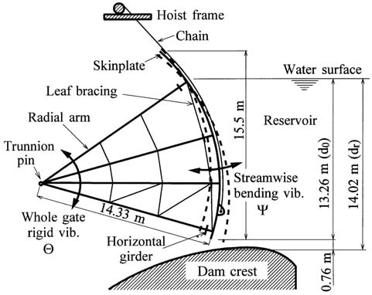

The segment gate rotates about a horizontal axis, which passes through the bearing center and usually coincides with the center of the skin plate curvature radius. By this arrangement, the resultant thrust from the water pressure passes through the point of rotation and has no tendency to open or close the gate. In some cases, the center of curvature of the skin plate is located above the bearing axis so as to provide a lifting moment, which helps the winch in the opening of the gate.

Large reverse segment gates have been installed, with success, in spillway works in the region of Bavaria. Some of these gates are listed below in the table, all supplied by M.A.N. All these gates have a flat skin plate and are provided with flap gates on the leaf top.

Reverse Segment Gtaes

|  |  |  |  |  |  |
| --- | --- | --- | --- | --- | --- |
| Year | Project | Quantity | Span (m) | Height (m) | Area (m2) |
| 1965 | Bittenbrunn | 3 | 24.0 | 7.8 | 187.2 |
| 1964 | Bertoldsheim | 3 | 24.0 | 7.0 | 168.0 |
| 1966 | Kleinosthei | 5 | 21.0 | 6.6 | 138.6 |
| 1956 | Feldheim | 3 | 16.0 | 8.2 | 131.2 |
| 1961 | Offingen | 3 | 19.0 | 6.6 | 125.4 |

**3.9 SECTOR GATE**

The sector gate has a curved skin plate like that of the segment gate, but continued in its upper portion by a full surface, in the radial direction, up to the bearings, giving to the leaf profile the aspect of a circular sector (fig. 2.65). The gate is hinged at the downstream side and its leaf has the shape of an open body on its lower radial side. The first designs of sector gates provided also the closure of the lower side, producing a closed section in shape of real sector, hence its name.

In the raised position, the sector gate is kept open by water pressure on the inner face of the upper radial side. Gate operation is fully hydraulic and hoists are not required. The reservoir water, when allowed to flow into the recess chamber, will cause pressure on the bottom of the gate, thereby rotating it upward. The gate is lowered through opening of the outlet valves, which drain the water held in the chamber. Hinge bearings are spaced from 1.5 m to 3 m, and fastened to the chamber. The skin plate radius is taken as 1.4 to 2 times the gate height.

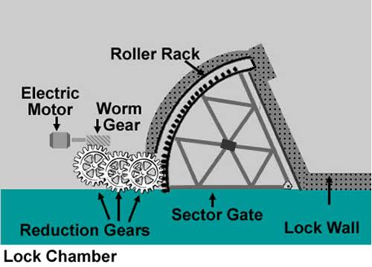

The sector gate provides a precise and safe automatic control without resort to an external power supply. Sector gates can be made as long as desired. Heights of gate are limited to about 8 m. This type of gate is regularly used in Europe, chiefly in sites where considerable quantity of floating material or ice need to be discharged over the structure.

In Brazil, the only installation of this type of gate occurred in 1924 at the Ilha dos Pombos dam, on the Paraiba river, where three sector gates were installed, with a width of 45 m, height of 7.4 m, and radius of 10.6 m.

**3.10 STONEY GATE**

This gate has a roller train on either sides of its frame, composed of horizontal rollers held in position by two vertical plates. The roller trains are placed between the gate leaf and the wheel tracks. The roller train is lifted by a steel cable running over a loose pulley installed on top of the vertical plates, with one end attached to an elevated fixed point on the pier and the other end being attached to the gate.

The main disadvantage of the Stoney gate is the presence of statically undefined reaction forces due to the application of numerous rollers and their variable positions in relation to the gate frame during travelling. In addition, with the gate raised the rollers get exposed to the full impact of the water flow, leading to appreciable wear of rollers by erosion due to the sediment content in water.

Eight Stoney gates have been installed in the spillway of Ilha dos Pombos Power Plant, Brazil, with a width of 12 m; two of them are 11.2 m and six 7.6 m high.

The largest Stoney gates ever manufactured are installed in spillways and have the following dimensions:

|  |  |  |  |  |
| --- | --- | --- | --- | --- |
| Year | Project | Span (m) | Height (m) | Outstanding Feature |
| 1925 | Landenburg | 40.0 | 8.3 | Largest span |
| 1929 | CizeBolozon | 10.0 | 17.0 | Greatest height |

Because of its high cost and greater need of maintenance, this type of gate is no longer specified. The most recent application occurred in 1961, in the El Infiernillo Dam, Mexico, where two Stoney gates were installed with a width of 3.3 m and a height of 8 m.

**3.11 DRUM GATE**

The drum gate leaf is a horizontal floating vessel, formed in the shape of triangular prism and hinged along its lower upstream edge (fig. 2.72). Upstream and downstream sides are made of curved plates, whereas a flat plate forms the bottom of the gate. The structure is closed on the two sides by flat plates.

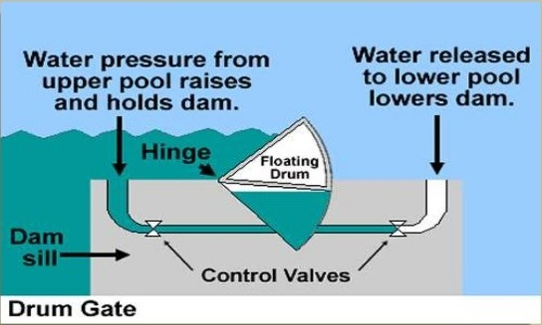

This type of gate is rather heavy but its operation is fully hydraulic and no hoists are required. All sides of the hydraulic chamber are sealed and the gate position is controlled by the application of headwater pressure underneath. Water supplied to the hydraulic chamber is controlled by slide or butterfly valves installed in special chambers built within the dam structure.

The gate is kept in the fully closed position by the water pressure underneath the bottom side. The resultant water thrust on the bottom side creates a moment about the hinge axis capable of overcoming the moments produced by the water pressure acting on the upstream skin plate and its dead weight.

The example of drum gate is the Hamilton Dam gate, having a width of 90 m and a height of 8.5 m.

**3.12 BEAR – TRAP GATE**

The bear – trap gate is formed basically of two flat leaves, which are hinged horizontally at their lower ends. The free end of the upstream leaf presses continuously on the downstream leaf by means of rollers. The leaves form a broad inverted V in the raised and intermediate positions.

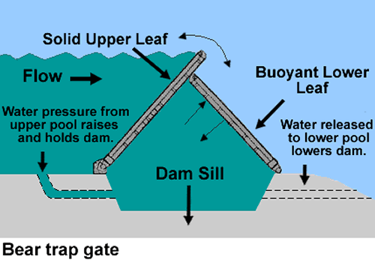

The two leaves form a closed hydraulic chamber in conjunction with the base, connected with the upstream pool by conduits in the piers or the sill. The bear – trap gate is hydraulically operated and does not require hoists. Filling of chamber causes a pressure to be exerted underneath the downstream leaf, which is provided with floating tanks. This leaf raises and pushes the upper leaf with it. Emptying the chamber is achieved by connecting it with the lower pool and causes the lowering of the gate.

Bear – trap gates have been used in low-head installations as regulating gates in movable navigation dams and for log-sluicing operations. Its height is usually limited to 4 m. The principal advantage of the bear – trap gate is the considerable saving in the costs of substructure owing to the elimination of a deep hydraulic chamber. The bear – trap gates requires a pressure from 6 to 12 kPa under the lower leaf to begin its upward movement from the critical lowered position.

The largest reported bear – trap gates are the seven 33.7 m wide and 5.5 m high gates installed at the Day Dam, in Vietnam. In the USA, up to 1948, bear – trap gates have been installed in pairs at all wicket dams on the Ohio River, except dam No. 21 and 48. These gates are up to 33.6 m wide and 4.6 m high.

**3.13 VISOR GATE**

Its name derives from the resemblance with the visors worn by the Middle Age Knights in their helmets. The gate leaf has a box – type structure with a semi-cylindrical skin plate, pivoted on horizontal pins (fig. 2.89). The leaf is designed as three hinged arc.



Visor gates may be designed to seal in any direction. In the closed position, the leaf presses continuously against the sill. In the open position, it allows vessels to pass under the leaf, presenting no problem to navigation. The water thrust on the gate is transferred into the concrete structure through the pins fastened on the piers.

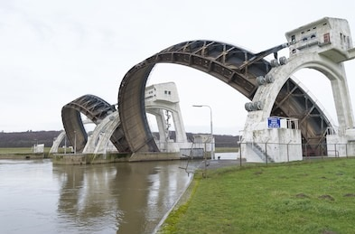

Few applications are known of this type of gate. In the city of Osaka, Japan, three gates were installed in 1970, each with a clear width of 57 m and a height of 11.9 m, to control the tides. These gates are designed for a head of 10.9 m on the sea side and 6.7 m on the river side. The support length is 66 m and each gate weighs about 5.2 MN.

**3.14 FIXED WHEEL GATE**

The fixed-wheel gate is certainly the most common type of gate and consists basically of leaf, wheels, shafts and seals (fig. 2.76). In general, the leaf is formed by a flat skin plate and stiffened by horizontal girders and ribs. On each side of the leaf, the ends of the horizontal girders are welded to a vertical girder. Wheels are mounted on shafts fixed laterally to the leaf on the vertical girders and have the double function of reducing the friction forces and the transmission of the water load to the embedded parts.

The field of application of fixed – wheel gates is very large, as listed below:

|  |  |  |  |  |  |
| --- | --- | --- | --- | --- | --- |
| Project | Use | Span (m) | Height (m) | Head on sill (m) | Supplier |
| Sao Simao | Intake | 6.50 | 11.3 | 43.78 | Voith |
| Jurumirim | Bottom outlet | 3.25 | 4.70 | 26.50 | DSD-NOELL |
| Sobradinho | Lock gate | 17.0 | 18.50 | 18.00 | ALSTOM |
| P. Colombia | Draft Tube | 10.85 | 5.43 | 35.6/47.0 | ALSTOM |
| Bariri | Spillway | 11.50 | 6.00 | 6.00 | ALSTOM |

Its main application, however, is made in installations requiring guard gates capable of closing under their own weight, as in high-head intakes.



Besides, the operation of fixed wheel gates in spillways requires the lifting of all their dead weights, even for minor control of the reservoir level. Especially in the event of small lifts of the gate, foreign bodies can enter the gap provided for the flow causing damages to the bottom seal when the gate is being closed. These considerations constitute the reasons for using the following alternative designs:

1. Multiple – leaf fixed-wheel gates – consists in the horizontal partition of the gate leaf into two or more sections, which can be independently driven. The passage of floating bodies and the accurate regulation of the water level are achieved by lifting the upper section.
2. Double – leaf fixed-wheel hook gates – consists of two elements designed so that the upper one may be lowered, permitting discharge over the gate (fig. 2.79). Both elements can be lifted above the maximum water level.
3. Fixed-wheel gates with flap – consists in the installation of a flap gate on the top of the fixed-wheel gate (fig. 2.80). Lowering of the flap gate permits a precise regulation of the headwater level, as well as easy disposal of driftwood and ice.

**CHAPTER *4: HOISTS***

* 1. **INTRODUCTION**

Hoist is an arrangement for lifting the gate irrespective of type of gate. The hoists can be described into two types namely positive driven hoist and loose driven hoist.

In positive driven hoist, the driving arrangement is directly linked with gate either at the time of opening or closing of gate. Effort is required both at the time of opening and closing of gate. Also the connecting link has to bear both tension and compression. Hydraulic hoist, rack and pinion come under this category.

In loose driven hoist, the connecting link cannot transmit or withstand compression but can withstand tension. Thus for closing the gate, weight of gate should be more than the friction and buoyancy effect. Rope and chain hoists come under this category.

* 1. **CLASSIFICATION OF HOISTS**

1. **Based on drive**
2. Manually operated hoist
3. Electrically operated hoist
4. Float operated hoist
5. Hydraulic hoist
6. **Based on operating mechanism**
7. **Mechanical hoist**

Rope drum type hoist e.g. winches, chain pulley block

Drum hoist, mono rail crane, gantry crane etc.

Screw hoist

Chain and sprocket type hoist

1. **Hydraulic hoist**
2. **Based on mounting**
3. **Portable hoist**

Chain pulley block, portable worm gear hand hoist, winches, truck or crawler mounted cranes.

1. **Stationary hoist**

Such as screw hoist, rope drum hoist, chain and sprocket.

1. **Moving hoist**

Such as rail mounted cranes, mono rail crane and gantry crane.

* 1. **TYPE OF HOISTS**

1. **Hydraulic hoist**

Hydraulic hoist consists of a cylinder mounted on a civil work and having its rod extending downwards. Gate is connected to the rod by any type of coupling or hook. The hoist cylinder is operated up and down by hydraulic power unit consisting of motor, pump, oil tank, pressure control, limit switches and direction control valves etc.

1. **Chain hoist**

Chain hoist consist of wire rope, drums, shaft and electrical motor. It is comparatively simpler than the hydraulic hoist, but their working speed is limited and maintenance effort is more.

***CHAPTER 5: NATHPA JHAKRI HYDRO POWER PROJECT- CASE STUDY***

Nathpa Jhakri hydro-electric power station is run-off-river scheme on river Satluj with an installed capacity of 1500MW. The project will generate 6951MU of electrical energy in a 90% dependable year and 7351MU in an average year. Nathpa Jhakri (1500MW) is the largest hydro-electric power station in India.

Nathpa Jhakri project is being executed by NJHPS in a joint venture of the Government of India and Government of Himachal Pradesh, both sharing project cost in the ratio of 3:1 respectively.

The main components of Nathpa Jhakri project are :

* A 67.5m high diversion dam on Satluj river
* An underground desilting complex
* A 27.4m long head race tunnel
* A 301m deep surge shaft
* Steel lined pressure shaft
* Underground power house and transformer hall

**NATHPA JHAKRI PROJECT SALIENT FEATURES**

* It has a 62.5m high concrete gravity dam at Nathpa village of Kinnaur district of Himachal Pradesh and it diverts 486 cumecs of water through four power intakes.
* Four underground desilting chambers each 525m in length, 16.31m in width and 27.50m in depth which is the largest underground complex for desiltation in the world.
* A head race tunnel of 10.5m diameter and 27.39km in length making it longest power tunnel in the world and terminates to 21.6m/10.2m diameter.
* It has the deepest surge shaft which is 301m deep.
* There are three circular lined steel pressure shafts each of 4.9m diameter and 571m to 622m length which feeds six generating units.
* The six generating units are operated by Francis turbines of 250MW capacity each and utilizes design discharge of 405 cumecs and design head of 425m.
* The discharge tubes to the collections gallery and are used for discharging the water back into the river through 10.15m diameter and 982m long tail race tunnel.
* The project has an underground Transformer hall and Power house. There is a Surface Switch Yard for evacuation of power through two transmission lines.
* The project also has an interesting feature of Sholding Work Complex which enables diverting water of sholding stream into HRT.
* Annual energy generation of 6750.85 million units in a 90% dependable year.

**OVERVIEW OF NATHPA JHAKRI HYDRO POWER STATION**

The 1500MW Nathpa Jhakri Hydro Electric Power Project (NJHPP) envisages to harness the hydro power potential in the upper reaches of Satluj River in the south west of Himalayas in Himachal Pradesh. The power house site is about 150km from nearest rail head (narrow gauge) Shimla. The project is stretched over a length of about 50km from the dam site to the power house on the Hindustan-Tibet road (NH-22).

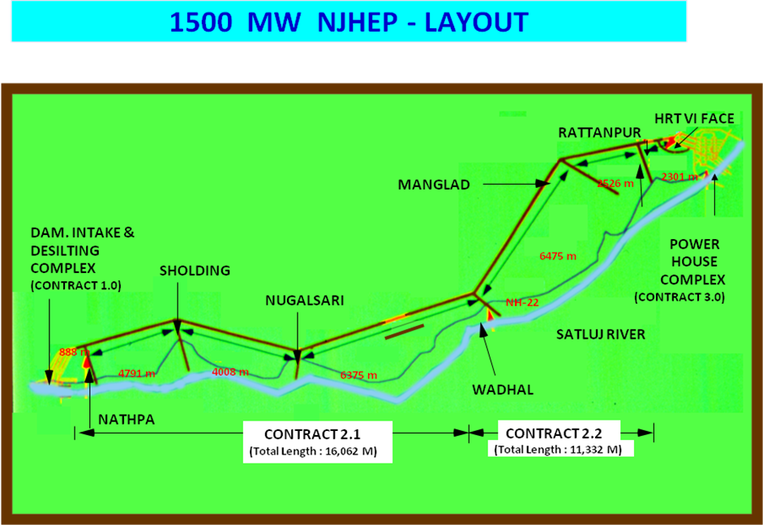

**NATHPA JHAKRI POWER PROJECT STATISTICS**

|  |  |
| --- | --- |
| **DESCRIPTION** | **AS PER REVISED COST EXTIMATE** |
| Location:  State  District  Vicinity  Diversion Dam:  Type  Maximum height above foundation level  Full reservoir level  Minimum draw down level  Desilting Arrangement:  Type  Number and size  Flow through velocity  Particle size to be removed  Head Race Tunnel:  Shape & type  Diameter  Surge Shaft:  Type  Diameter  Total height  Pressure Shafts:  Type  Power House:Type  Size  Type of turbine  Gross head  Design head  Number and capacity of generating units  Tail Race Tunnel:  Size  Length  Power Potential:  Energy generation in a mean year  Energy generation in a dependable year | Himachal Pradesh  Kinnaur/Shimla  Dam downstream of Wangtoo bridge at Nathpa & power house near Jhakri village on left bank of river Satluj  Concrete gravity  62.5m  1492 m  1474.00m  Underground  Four parallel chambers each 525m x 16.31m x 27.5m  33.0 cm/sec  Particle greater than 0.2 mm  Circular, concrete lined  10.15m  Restricted office  21.6m circular for height of about 210.0m and a connecting shaft of 8.8m diameter and about 90m high  301.0m  Circular, steel lined with high tensile steel corresponding to ASTMA517 grade F of thickness varying from 26mm to 38mm, each bifurcating to feed 2 units 4.9m diameter and approximately 572m to 622m and 623m length  Underground  222m x 2om x49m  Vertical axis Francis turbine  486m  428m  6 x 250 MW  10.15m, circular  982m  7447MU  6951MU in a 90% dependable year |

**WATER CONDUCTOR SYSTEM**

1. **Dam**

The function of the dam is not only to raise the water surface to create artificial head but also to provide poundage. The dam is straight gravity type dam having a height of 62.5m on Satluj River at Nathpa to divert 405 cumecs of water through four intakes. It is built of concrete or stone mansonary on a rock hill. The length of dam at the top is 170.2m consisting of 63m as low structure and 88.2m as sluice block section with each having the size of 7.35m with crest at 1458m.

Catchment area of dam : 49820 sq.km

Design flood :5660 cumecs

Maximum water level :1492m

Minimum water level :1474m

1. **Gates and hoists**

|  |  |  |  |
| --- | --- | --- | --- |
| **S.No** | **GATES USED** | **TYPE OF GATES** | **HOIST/CRANE USED** |
| 1. | Dam | * Dam Sluice Stoplogs * Radial Sluice Gates * Intake Stoplogs * Intake Gates | Gantry Crane  Hydraulic Hoist  Stoplog monorail hoist |
| 2. | Desilting Chambers | * Silt Flushing Gates * Headrace Tunnel Intake Gates * Silt Flushing Tunnel Portal Gate | 5 ton EOT crane  Rope Hoist  45T capacity rope drum hoist |
| 3. | Sholding Complex | * Inlet Tunnel Stoplogs * Inlet Tunnel Gate * Conveyance Tunnel Gate * Outlet Tunnel Gate * Trench weir Bulkhead gate | 5T Monorail crane  5T capacity EOT Crane  Rope Drum Hoist |
| 4. | Powerhouse Complex | * Draft Tube Gates * Tail Race Outfall Structure Stoplogs * Tail Race Outfall Gates * Rampur Scheme Headrace Tunnel Intake Gates | Overhead Traveling Crane  35T capacity gantry crane  Rope Hoists |

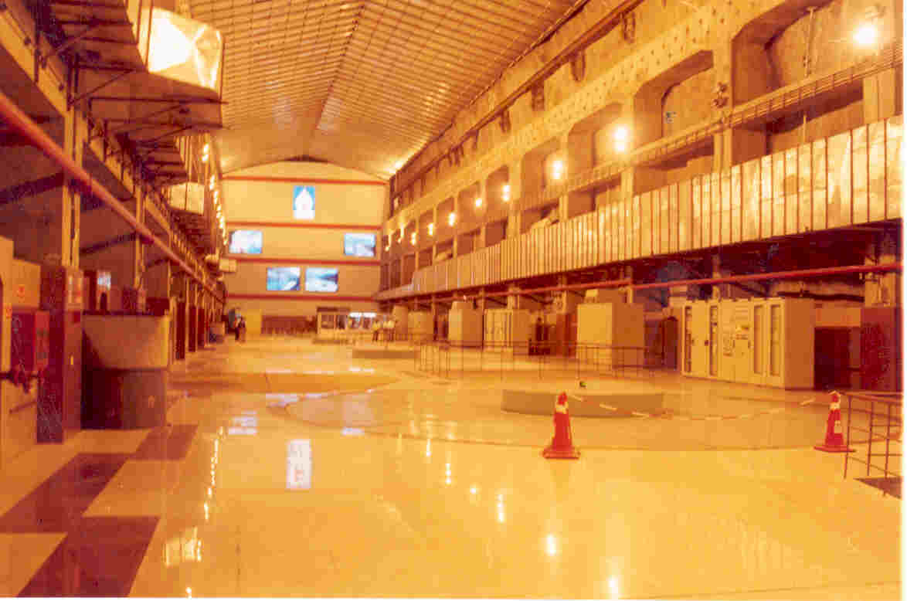

Inside view of Power House

1. **Turbine**

The turbine used in Nathpa Jhakri Power Project is the “Vertical Francis Turbine”. The rotating parts of the turbine unit have a vertical axis of rotation. This turbine belongs to the reaction turbine family. The water is under pressure as it enters the runner and completely fills all its channels as it passes through it. The head for the Francis turbine is usually between that of Kaplan (low head) and Pelton (high head) turbines.

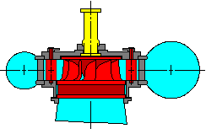

Diagrammatic view of Francis turbine

1. **Turbine Function**

The water from penstock enters the spiral casing. In the spiral casing, water spreads around the whole circumference by stay vanes and leads to the guide apparatus. The guide apparatus has movable vanes which are controlled by the

governor and can be set independent of the output. After this impact, the water continues flowing in the draft tube and out through the tail race tunnel. The effect is transferred from runner to the generator, which is directly connected to the turbine shaft. The turbine develops power partly due to the velocity of water and partly due to the difference in pressure acting on front and back runner buckets.

Such a turbine essentially consists of guide apparatus outer ring consisting of stationary guide blades fixed to the casing of turbine and inner ring consisting of rotating blade forming a wheel or runner. As the water passes over the rotating blades of the runner, both pressure and velocity of water gets reduced causing a reaction force on the turbine. The guide blades of the turbine are pivoted about an axis parallel to the turbine axis so that the quantity of water entering in the turbine may be regulated by turning them simultaneously in one direction or the other. Their motion is automatically controlled by governor. Francis turbine can be constructed vertically or horizontally but the Horizontal Francis turbine is more accessible and has higher speed. But for a large size machine, Vertical Francis turbine is preferred to affect higher speeds. As compared to Pelton Wheel turbine, a Francis turbine offers an advantage of higher efficiency at full load. At 75% of full load, this turbine can be designed for speeds higher than the Pelton Wheel turbine. The gross head of the Francis turbine is 488m and the design head is 425m.

1. **Turbine Components**

* Rotating parts
* Turbine guide bearings
* Turbine upper and lower cover
* Guide vanes
* Governor regulating mechanism
* Spiral casing
* Draft tube
* Shaft seal
* Dewatering system

1. **ROTATING PARTS**

There are mainly three rotating parts in a turbine :

1. **Runner**

Runner is being welded from crown and band of stainless cast steel to vanes from stainless steel plates. The vanes are made from machines. The crown band has “roots” towards the vanes. Air for stabilization purpose is allowed through the center of runner via shaft.

Seal and drilled holesare made in the turbineshaft flange. The moment of force on the runner is transferred to turbine shaft through the shear pin connection. The coupling bolts between turbine shaft flange and runner are tensioned by means of a hydraulic wrench.

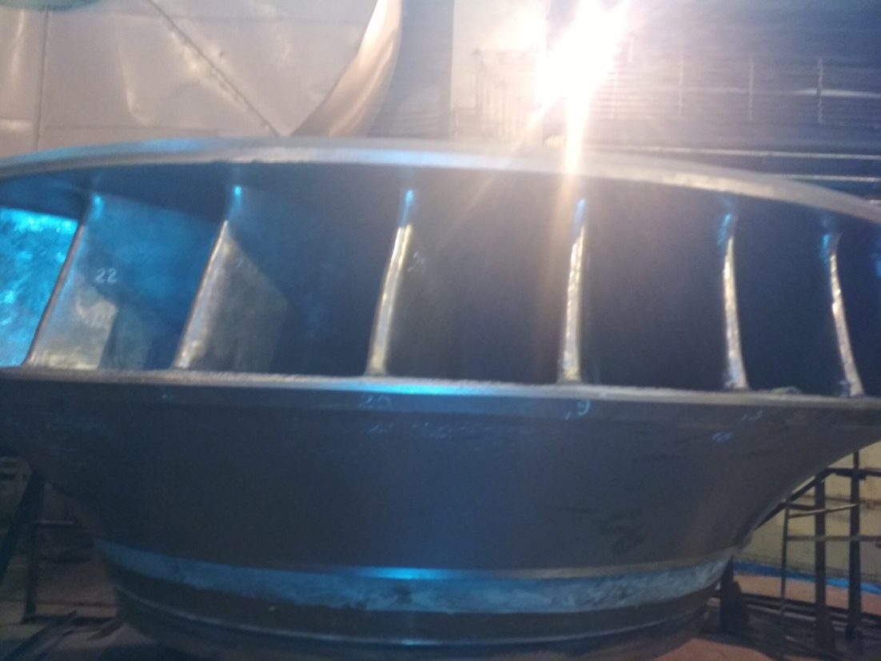

Rotating part : Runner

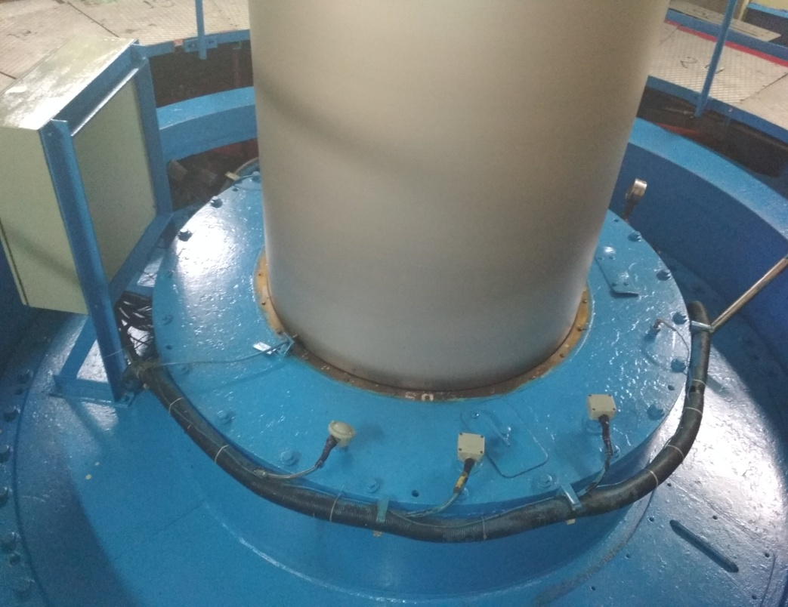

Rotating part : Turbine Shaft

1. **Turbine Shaft**

Turbine shaft is made of SM steel with flanges hammered out at both the ends. The turbine shaft and generator shafts are connected by flanges. The connection primarily transfers the moment of force through the shear studs.

1. **Oil Slinger**

The oil slinger is located below the turbine bearing and is connected to the turbine shaft. Its purpose is to collect the oil from turbine bearing and bring the oil into rotation inside the slinger cylinder during operation. From the slinger cylinder, oil is catched by the oil scraper and is transferred to the oil cooler and the oil bearing reservoir.

1. **TURBINE BEARING**
2. **Bearing Design**

The turbine bearing is radial type vertical guide bearing. The bearing consists of a strong construction and simple manner of operation which requires less maintenance. The bearing house is split type and is attached to the upper turbine cover. It has two manhole hatches for access and inspection of the shaft seal and pipe connections. The bearing shell consists of two segments which are bolted together and are attached to the upper side of bearing house. The shell has four oil packets as well as four babbits.

The surface is machined in wedge shaped entrances which ensure a stable centering of the turbine shaft. The bearing is fitted with an inspection hatch, external oil cooler,dip stuck for oil slinger, fluid level gauge for bearing housing, level switches and thermometers for surveillance. The external oil cooler automatically start operation when the water cooling system is started.

1. **Bearing Function**

When the unit is started, the oil slinger starts rotating and the oil is slung up into the cylinder section covering the vertical side with a layer of oil. The thickness of the oil layer is being determined by the position of oil scraper. The amount of oil in oil slinger is regulated by means of an oil scraper which is attached to the bearing shell. When sufficient rotating speed is achieved, damming up pressure becomes strong enough to force the oil up ascending pipe through the oil cooler and out into the bearing house. From there, the oil flows down through four windows in bearing house cover and spreads into four oil pockets in the bearing shell. A film of oil follows with shaft in the wedge shaped entrance onto the bearing shell and builds up the guiding oil layer.

1. **TURBINE COVER**
2. **Upper Cover**

The upper cover is bolted up to the spiral casing ring.

It serves as a bearing for regulating ring and as a support to the upper stationary labyrinth seal, turbine inner cover with shaft seal and the longest trunnion of the guide vanes. The interchangeable upper stationary labyrinth seal is made of forged steel and is bolted to the cover. The surface of the labyrinth seal faces equivalent seal surface on the upper rotating labyrinth seal bolted to the runner.

1. **Lower Cover**

The lower turbine cover is bolted to the spiral casing stay ring. It serves as a support for short trunnion of the guide vanes, lower stationary labyrinth seal and draft tube cover. Aluminium Bronze supporting sleeves are also installed for the guide vane bearing. Corrosion resistant austenite steel is welded into wearing surface of lower turbine cover between the wear ring and lower labyrinth seal.

1. **GOVERNOR**

The turbine consists of two servomotors. The connection between servomotor and regulating ring consists of an adjustable connecting rod and a spherical bearing. It senses the speed of turbine rotation and generates a signal which is proportional to the difference between turbine speed and governor speed. This develops a hydraulic control signal sufficientto control the turbine. The adjustable rod is used for pre-tensioning the guide apparatus and while doing so the guide vanes are given a moment which produces a force

towards the closed position. This compensates for the slack deformation in the lever and link connection. Also it provides a closing force greater than or equal to hydraulic opening force on the vanes with full pressure inside the spiral casing.

1. **SPIRAL CASING**

Spiral casing is the waterway between penstock and guide apparatus. It is being constructed to ensure constant water speed around whole circumference of the guide apparatus. The spiral casing is built from a stay ring and a plate shell to an all welded construction of fine grained shell steel. Spiral ring consists of an upper and lower ring connected by a welded stay. The stay is shaped in a hydraulic favorable way to lead water towards guide apparatus with least possible loss.

Spiral casing is fitted with outlets for taking the index measurements and also a manhole for inspection. Outlets for pressure measurement, dewatering and air escape are positioned on expansion box at the inlet of spiral casing. The main part of spiral casing is concreted in a solid slab being supported against the downstream rock wall. The hydraulic force acting on spiral casing inlet is thereby balanced against the rock.

1. **DRAFT TUBE**

Outlet consists of a draft tube and a draft tube steel lining continuing with a concrete lined tunnel and forms waterway from runner to the race channel. Draft tube cone is being welded and consists of two parts. The upper part made of stainless steel is bolted to the lower fixed labyrinth seal. The lower part is attached to the draft tube steel lining with a flexible flange connection. It has one manhole for access to the draft tube and is fitted with four covered stub pipes for installation of an inspection platform. The draft tube can be emptied into dewatering pit by slight extension of the cross section in direction of flow from the runner outlet to the end of plate covering. The draft tube has ten segments with plate thickness of 30mm and total weight of 34 ton.

1. **SHAFT SEAL**

Shaft seal is attached to the inner cover, which is again attached to the upper turbine cover. Due to the rotation of water in the gap between runner and upper turbine, the shaft seal gap gets covered when turbine is in operation. When the shaft comes to complete standstill, service seal gets closed, valves in drainage pipe get automatically closed and the flushing water pump gets stops. This ventilation takes place through a separate air pipe connected to the shaft seal support ring. The air pipe is fitted with a check valve which prevents tail water from leaking out during standstill.

11. **SHAFT SEAL FLUSHING WATER**

In order to prevent the contaminated water from entering into the shaft seal during start and stop sequence of the unit and during low rotating speeds to keep the shaft seal dry, the shaft seal flushing water system provides filter water at a sufficient water speeds. Intake is from pressure equalizing piping system between the upper turbine cover and the draft tube. A centrifugal pump pressurizes and flushes the strainer particlesabove 200microns. The system automatically gets into operation during start and stop of the unit.

1. **PENSTOCK DEWATERING SYSYTEM**

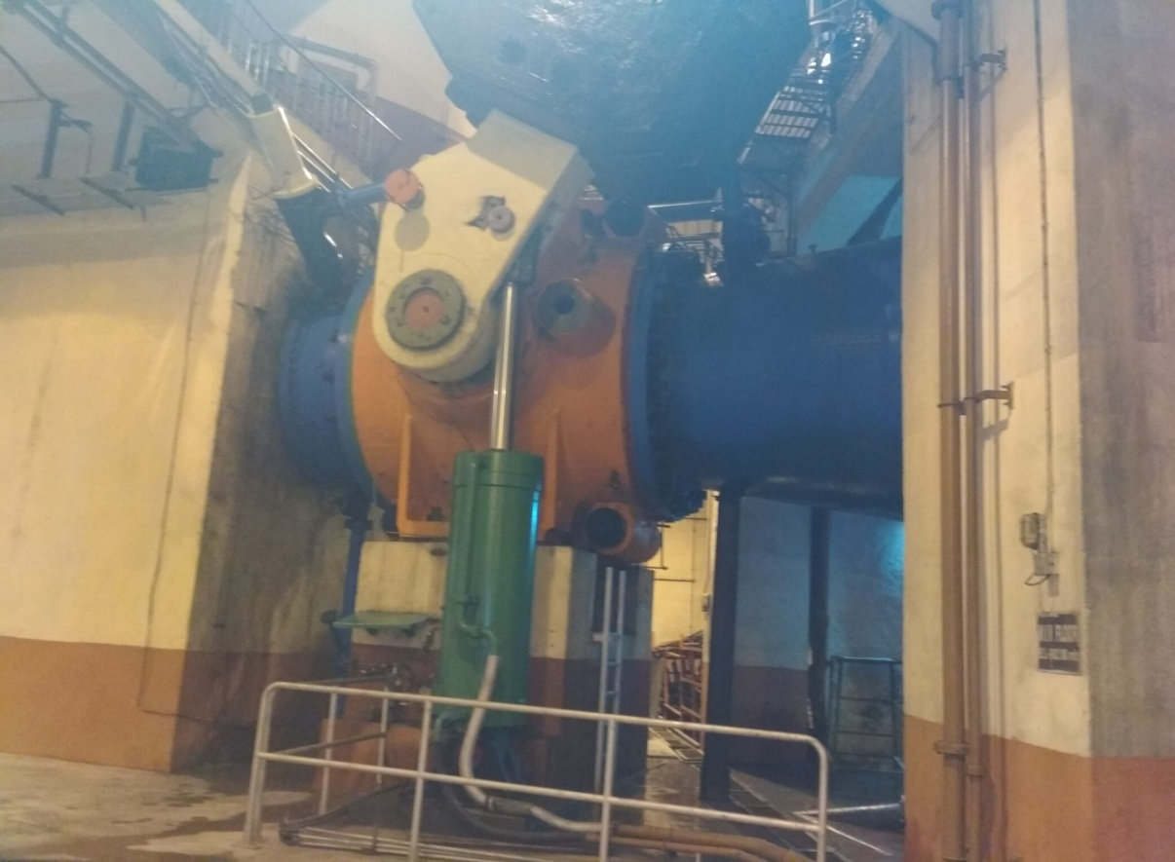

MIV system at Nathpa Jhakri

The dewatering system consists of one high pressure drainpipe for each individual unit. The inlet is upstream to MIV and the system consists of a gate valve and also a hand manufactured needle valve. Dewatering is done from penstock to draft tube down to the tail water level. After setting up of the draft tube gate, the remaining water gets drained through draft tube to the dewatering pit from where it is pump discharged outside the draft tube gate by dewatering system.



MIV in open position



MIV in closed position

1. **GUIDE APPARATUS**



The governors action on two main servomotors is transferred by the regulating ring. The actual guide apparatus consists of 23 guides and checkplates on the upper and lower turbine covers as well as on the guide vane lever and the links. The guide vanes are made of forged stainless steel and shaped to provide best possible hydraulic conditions.



Opening and closing of Guide Vanes

The guide vanes have bearings on upper and lower turbine covers. These are self-lubricating type slide bearings along with a Teflon covering. The coupling between the guide vane and the guide vane lever is a pure friction coupling, thus allowing guide vane to slide away in case a foreign object prevents the guide vane from being closed. An alarm in such case gets activated. The guide vane lever and the regulating ring are connected with the help of links. The links are joined by self-lubricating type bushing on stainless steel pins which are attached to the regulating ring and the guide vane lever respectively.

1. **GENERATOR**

The vertical mounted synchronous generator converts the hydraulic energy of water into electrical energy. Generator is vertical shaft type having salient poles with closed air circuit ventilation and is suitable for coupling to machine turbine. It has static excitation system energizing the field coils. The slip rings, permanent magnet generator and mechanical over speed device is located on fabricated shaft which in turn is fitted to spider rotor. The speed of turbine wheel must match the synchronous speed of generator. The generator has a combined thrust and a guide bearing below the rotor. Generator has a certain rating and characteristic since the components are designed to withstand seismic forces as are applicable.

1. **GENERATOR COMPONENTS**

* Stator
* Rotor
* Bearing
* Excitation system
* Air water cooling system
* Slip ring and brush gear

1. **Stator**

The rotor winding is excited by direct current and induces a voltage in the stator winding which is taken by bus bar to the

frame, laminated stator core and stator winding embedded in slots of the laminated core.

* **Stator frame**

The stator frame is built from weld able steel plates and has an adequate depth to prevent distortion during operating conditions and also during its transportation.

* **Stator core**

The stator core is built by stamping high grade non-ageing cold rolled silicon alloy with varnished insulation on both sides. The segments are attached to the frame by dovetail notches engaging with the corresponding dovetail key bars welded to the stator frame.

1. **Rotor**

The rotor and rotor windings are excited by direct current and generates a constant magnetic field. The rotational movement at specific synchronized speed induces a sinusoidal alternating current voltage in all phases of the stator winding. The rotor is designed to safely withstand all mechanical stresses imposed at maximum runway speed. The static and dynamic balancing of the rotor is carried out as a part of pre-commissioning test at the site. All values of the rotor vibrations are kept within allowable limits according to the preset standards.

* **Housing**

Depending upon the operating conditions of machine, the generator housing absorbs mechanical loading being generated and transfers it to the foundation.

* **Anti-condensation heaters**

Low temperature is maintained to prevent condensation of the winding during shut down period. System is mounted below the winding located under lower air guide. It is tubular or box type construction consisting of a coiled resistant wire embedded in an electrically insulating and heat conducting compound being protected by a metal brush.

1. **Air Water Cooling System**

Mechanical and electrical losses arise during the course of operation due to temperature rise of the components. The bearings are water cooled while the stator and generator rotor are air cooled. The generator consists of a closed cooling circuit and thus is sealed from all sides against the surrounding surface. The foundation walls to the enclosure from the machine and the outer cover separates generator from the turbine room. The enclosure at the circumference is provided by the generator pit. The cool air enters tangentially through the rotor and enters the stator through gaps. Air water cooler is arranged after the stator removes heat which the air absorbs.

1. **Slip Ring and Brush Gear**

The collector made of mild steel is mounted at top of the generator tube shaft. The brush gear for collector is mounted on insulated stud supported at top bracket and is arranged to permit convenient access for maintenance and inspection. Insulation of slip rings and connections is non-hygroscopic and is oil resistant. The slip ring system transfers the direct current necessary for excitation of rotor from fixed brushes to the slip ring and thus to the rotor poles.

1. **Bearings**

Two different types of bearings are attached to the rotor i.e. thrust bearing and guide bearing. The thrust bearing must take up the entire weight of the rotating components of the machine set (rotor and turbine) and axial thrust of hydraulic machine. Both journal bearing and turbine ensure a cantered machine run from the standstill up to the runway speed of the turbine.

* **Thrust bearing**

Thrust bearing is pivoted segmental pad type bearing in which stationary part consists of a set of babbit segmental pad supported on a circular pad made of alloy steel forging. The bearing is self-lubricated and is immersed in an oil bath in which plug in type water cooled oil coolers are placed to remove bearing loss. Radial and circumferential movement of the pads is prevented by means of stoppers.

* **Guide bearing**

The guide bearing is pivoted pad type bearing consisting of an arrow of white metal parts arranged in a support ring to bear the journal surface. A pivot bar is bolted to the back of each guide pad to enable pad to rock slightly to take up a suitable position and facilitates formation of oil film while running. The air surface above oil surface is vented to the atmosphere by vapor pipes and air pressurized vapor seals are fitted to prevent the escape of oil vapors into generator air circuit.

**MAIN ELECTRICAL EQUIPMENTS**

1. **Synchronous Machine or Generator**

It is a three phase double excited machine because its field winding is energized from a dc source and armature winding is connected to an arc source. Its working as a generator is to deliver or export ac power. A synchronous generator is universally employed for generating three phase power at all the generating stations. Most synchronous motors are silent pole type as they are most suitable for slow speeds water turbine generators known as Hydrogenates. Power house consists of six generators each having 250MW capacity and are driven at speeds of 300 rpm. Each generator has 96 total brushes in which 48 are positive and 48 are negative. There are two slip rings with one positive and other negative.

The slip ring gives excitation current to rotor through brushes according to load requirements.

General specification is as follows :

Rated speed : 300 rpm Turbine rated head : 428m

Rated output : 250MW Rated output (generator) : 278MVA

Power factor : 0.9 Terminal Voltage : 15.75 kV

Manufactured by Alstom / Germany

1. **Excitation System**

In large synchronous machines, the field winding is always provided on the rotor. Some important excitation systems are as follows :

1. **DC Exciters**

This is an old conventional method of exciting field winding of the synchronous generator. Three machines namely pilot exciter, main exciter and a three phase alternator are kept mechanically coupled and are thus driven by same shaft. Pilot exciter feeds the field winding of main exciter. The dc output from main exciter is given to the field winding of the main alternator through brushes and slip rings. As also associated with slip ring, brushes and commutators with the increase in alternator rating, the conventional method of excitation suffers cooling and maintenance problem.

1. **Static Excitation**

The excitation voltage for main alternator field is drawn from the output terminal of 3-phase alternator. For this purpose, a three phase transformer TR steps down alternator voltage to the desired value. This three phase voltage is fed to 3-phase full convertor bridge using thyristors. The power output from the thyristors is delivered to field winding of main alternator through brushes and slip rings. For initiating the process of static excitation, firstly all field windings are switched on to the station battery bank to establish the field current in the alternator. The alternator is adjusted to the rated speed.

1. **Braking and Jacking System**

The generator brakes consist of a number of steel shoes mounted on a vertical piston moving in cylinder and operate against a polished circular steel brake located underside of the rotor. Brakesare automatically applied when speed of rotor reduces to a preset value and stay applied continuously so that the unit stops completely. The brakes also serve as a convenient means for jacking the rotor for the maintenance purpose with a complete hydraulic jacking unit. Limit switch is provided which shows the indication that the rotor is raised to maximum possible limit. The arrangement of piping is such that after jacking system is used, air under pressure can also be applied to the system to clear the oil pipes.

1. **Brake Dust Collector**

Brake dust collector consists of an extraction unit, a hopper around brake assembly for tapping brake dust and flexible hoses for connecting hoppers to extraction unit. This unit has a motor driven exhaust fan and is fitted with a sheet steel bin for collecting heavy dust. The lighter air born particles are collected by a suitable fabric based filter. Starter panel for motor also has a provision of automatic start and stop.

1. **Oil Vapor Extraction System**

Oil vapor extraction system sucks off vapors of generator bearing. The oil vapors are generated during operation and lead to the filters outside the generator room. The pollution created by machine is in this way avoided.

* **Generator**

As soon as generator starts running at the presetoperating temperature, oily fog gets developed in bearing oil container by very finely distributed oil drops. “Breathing” oil in the bearing or pressure difference inside and outside of bearing causes oil vapors which are mixture of air and oil particles that produce a different wetting of parts and surfaces. Damp places result in an ideal background for dirt beginnings. During high speed of rotor or simply heavy load, differential pressure increases between the bearing chamber and the environment. To prevent failure of bearing seal, generator is equipped with a special oil vapor suction system.

* **Design and Function**

Two pipelines are attached parallel above upper and lower bearing chamber. These pipes lead outwards to two suction filters. The particles separated by the filter, run off inside these separation pipes. The ventilator for production of the suction flow is inserted above separation pipe within clean air side. An activated carbon filter is mounted to absorb odor and gases behind the electrostatic unit. Cleaned air is blown by the activated carbon filter in open air.

1. **Generator Transformer**

A single phase 102 MVA, Ynd11* type generator transformer is used. The transformer consists of different parts such as :

1. **Conservator**

Conservator is generally used to protect transformer from failure and to conserve oil from deterioration and losing its insulating property.

1. **Silica Gel Dehydrating Breather**

Breather is used to prevent the entry of moisture inside the transformer tank. The breather consists of a silica gel. When air flow in and out of the transformer due to contraction or expansion of oil inside the tank, silica gel absorbs moisture and allows the moisture free air to enter inside transformer.

1. **Gas Operated Relay or Buchoulz**

It is a gas actuated relay used for protecting oil immersed transformer against all type of faults. It indicates presence of gases in case of some minor faults and in case of major fault it takes transformer out from the circuit.

1. **Bushing**

Bushingis made from a highly insulating material to insulate and bring out terminals of transformer from the container.

1. **Oil Gauge**

Every transformer is provided with an oil gauge to indicate the oil level. Oil gauge may be provided with alarm contacts which give an alarm when oil level drops beyond a certain permissible height due to some oil leakage.

1. **Tapping**

Transformers are usually provided with few tappings on the secondary side to vary the output voltage for constant input voltage.

1. **Radiator**

In large capacities transformers above 50kVA, the increase in oil temperature is quite high. On account of losses in the transformer, oil near the winding gets heated up and travels

upward along the winding and returns back through the side pipes of the radiator.

1. **Winding Temperature Indicator**

It is a device which indicates temperature of the winding of transformer and also possible damage to the transformer due to overload. Sensing bulb of dial thermometer is inserted inside the heating coil and the terminals of heating coil are connected to the temperature gauge.

***CONCLUSION***

Industrial training is very much essential for every engineering student to have deep understanding of working culture of an organisation. It is also a great opportunity to acquire practical knowledge of the course studied during engineering.

During the training period at SJVN Ltd. I acquired in depth knowledge about various hydraulic gates along with their functioning. Also I learnt designing of vertical lift gates and its load calculations. I even learnt about various gate components like girders, seals, wheels and hoist assembly.

It was interesting to see how various concepts of Fluid mechanics and Strength of Materials were applied in real life applications like gate designing, thrust calculations and girder placement. It was also learnt that each aspect of designing is done by taking into consideration all latest Indian Standards (IS).

In end the industrial training proved to be a great learning experience. It helped me to acquire basic knowledge and skills that are required to work efficiently in corporate world. Also I highly acknowledge the continuous support and guidance of SJVN Ltd.